**ZINGPLAY BRAZIL PORTAL**

**Authentication**

**Version: 1.1**

Revision History

|  |  |  |
| --- | --- | --- |
| **Version** | **Date** | **Changes** |
| 1.0 | May-07-2019 | - Game Integration |
| 1.1 | May-30-2019 | - Update services |

Table of Contents

I.Introduction 2

II.API 2

1. URL 2

2. Account system 2

a. Common error 2

b. Register 2

c. Login 3

d. Change password 4

3. Integrate Game to ZingPlay Portal 4

a. GameID 4

b.Game run standalone using Portal authentication 4

4.Service 6

a. Get config IAP 6

b. Verify receipt IAP Google 7

c. Verify receipt IAP Apple 8

# I.Introduction

# II.API

## 1. URL

**-** Private: http://118.102.3.28:456

- Public: https://brazil-login.zingplay.com

## 2. Account system

### a. Common error

|  |  |
| --- | --- |
| **Status** | **Description** |
| 3 | Success |
| 101 | Invalid param: username, password, gameId |
| 108 | Invaild mac |
| -1 | Fatal error |
| -2 | Request body is invalid |
| 12 | Username is already existed |
| 13 | Username does not exist |
| 14 | Valid session id |
| 15 | Invalid session id |
| 16 | ZingPlay id does not exist |
| 17 | Invalid device id |
| 18 | Invalid partner id |
| 20 | Username contains forbidden word(s) |
| 30 | Username and password do not match |

### b. Register

|  |  |
| --- | --- |
| Request | |
| Params:  @POST  {  service_name : zacc_register  gameId :  username :  password : md5(password)  mac : md5(username+md5(password)+gameId+secretkey1)  } |  |

|  |  |
| --- | --- |
| Response | |
| {  "status" : [int] error code  "data": {   * zpid: id user * avatar: * acs: account status * sid: access token   }  } |  |

### c. Login

|  |  |
| --- | --- |
| Request | |
| Params:  @POST  {  service_name : zacc_login  gameId :  username :  password : md5(password)  mac : md5(username+md5(password)+gameId+secretkey1)  } |  |

|  |  |
| --- | --- |
| Response | |
| {  "status" : [int] error code  "data": {   * zpid: id user * avatar: * acs: account status * sid: access token   }  } |  |

### d. Change password

|  |  |
| --- | --- |
| Request | |
| Params:  @POST  {  service_name : zacc_changepwd  gameId :  sid : sessionId  oldpassword : md5(oldpassword)  newpassword : md5(newpassword)  mac : md5(sid+oldpassword+newpassword+gameId+secretkey1)  } |  |

|  |  |
| --- | --- |
| Response | |
| {  "status" : [int] error code  } |  |

## 3. Integrate Game to ZingPlay Portal

### a. GameID

Danh sách các game

|  |  |
| --- | --- |
| HTTP Request | |
| <https://brazil-login.zingplay.com/?service_name=getGameList> |  |

### b.Game run standalone using Portal authentication

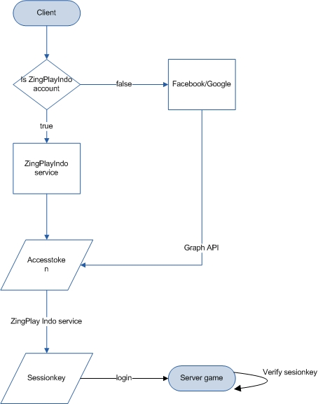

*Integration flow*

Steps:

***- Step 1: Get access token***

Login with ZingPlay Brazil account, call api Login for getting **sid**

Login with Google/Facebook account, use social Graph API or SDK for getting access token

***- Step 2: Get session key***

|  |  |
| --- | --- |
| Request | |
| Params:  @POST  {  service_name : getSessionKey  gameId :  clientInfo : (optional) embedded in sessionkey response  social :  accessToken : sid or access_token  deviceId :  mac : md5(social+accessToken+clientInfo+deviceId +gameId+secretkey1)  } |  |

|  |  |
| --- | --- |
| Response | |
| {  "error" : [int] error code,  "sessionKey": [String] access token,  "openId" : [String] user id  } |  |

**Error**

|  |  |
| --- | --- |
| **Error** | **Description** |
| 0 | Success |
| 101 | Invalid param |
| 108 | Invalid mac |
| 110 | Error processing |

***- Step 3: Login to Server game with session key***

Client send sessionKey to game server. Game server use SDK for decoding & verifying valid user.

Attention:

Decode sessionKey at server game using gameId + **secretKey2**

Contact [hieupt@vng.com.vn](mailto:hieupt@vng.com.vn) to get gameId, secretKey1, secretKey2

## 4.Service

### a. Get config IAP

|  |  |
| --- | --- |
| Request | |
| Service URL  https://brazil-login.zingplay.com/  Params:  @POST  {  service_name: get_config_iap  gameId :  package_name:  os : google/apple  mac : md5(os+package_name+gameId+secretKey1)  } |  |

|  |  |
| --- | --- |
| Response | |
| {  "error" : int  }  Chi tiết mã lỗi   * 0: success * 1: param * 102: invalid mac   os = google  {  “package_name” : ,  “license_key”: encrypted license_key,  “packages” : map 1A, 1B…  }  os = apple  {  “package_name” : ,  “packages” : map 1A, 1B…  } |  |

### b. Verify receipt IAP Google

|  |  |
| --- | --- |
| Request | |
| Service URL  https://brazil-login.zingplay.com/  Params:  @POST  {  service_name: verify_receipt  gameId :  package_name:  os : google  receipt_data: base64 encode receipt-data  sign : base64 encode sig  mac : md5(os + package_name + receipt_data + gameId + secretKey1)  } |  |

|  |  |
| --- | --- |
| Response | |
| {  “error” :  “status” :  “code” : 1A, 2A…  “orderId”: encrypted license_key,  “packageName” :  “productId” : 1A, 2A…  “purchaseTime” :  “purchaseState” :  “developerPayload” : game_to_purchase  “purchaseToken” :  “signature” :  “purchaseType” :  }  Chi tiết mã lỗi   * 0: success * 101: param * 102: invalid mac * 106: invalid productId |  |

### c. Verify receipt IAP Apple

|  |  |
| --- | --- |
| Request | |
| Service URL  https://brazil-login.zingplay.com/  Params:  @POST  {  service_name: verify_receipt  gameId :  package_name:  os : apple  receipt_data: base64 encode receipt-data  mac : md5(os + package_name + receipt_data + gameId + secretKey1)  } |  |

|  |  |
| --- | --- |
| Response | |
| {  “error” : = status,  “status ” : ,  “environment”: Production / Sandbox,  “in_app” :  list {  “quantity”:,  “product_id”: 1A, 2A…,  “transaction_id”: GPA.xxx,  “original_transaction_id”:,  “purchase_date”:,  “original_purchase_date”:,  “original_purchase_date_ms”:,  “expires_date_ms”:,  “cancellation_date”:  }  }   * status code: 0- success , <https://developer.apple.com/library/archive/releasenotes/General/ValidateAppStoreReceipt/Chapters/ValidateRemotely.html> |  |